LAB No: 06
TASK:01
Display the standard cost of all the products along with their categories according to the regions in which they were sold. Which region is the most and the least expensive according to the result retrieved?

According to the region vice, United States has most expensive standard cost of all products and Canada has least cost.

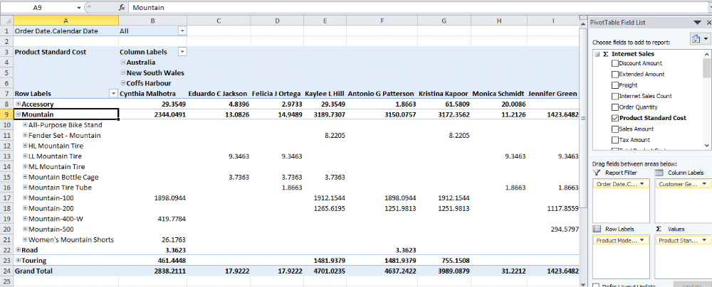
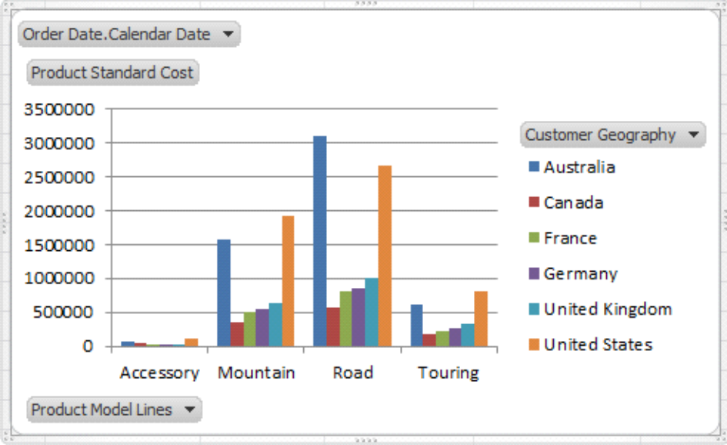

TASK:02
Display the Tax amount for customers according to their educations and occupations over calendar year. Do these factors impact the tax amount paid by a customer? Which class of customers pays the highest tax amount?

YES, It impacts on the tax amount because the customer which has occupation professinal pay high cost than others.
Bachelors with occupation Management pays highest tax amount.

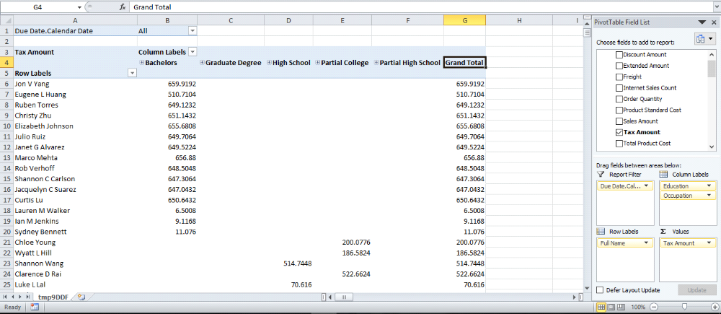

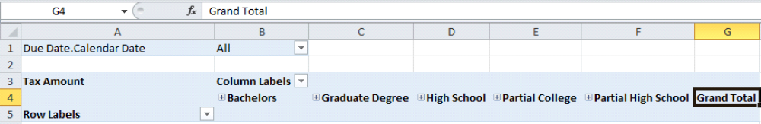

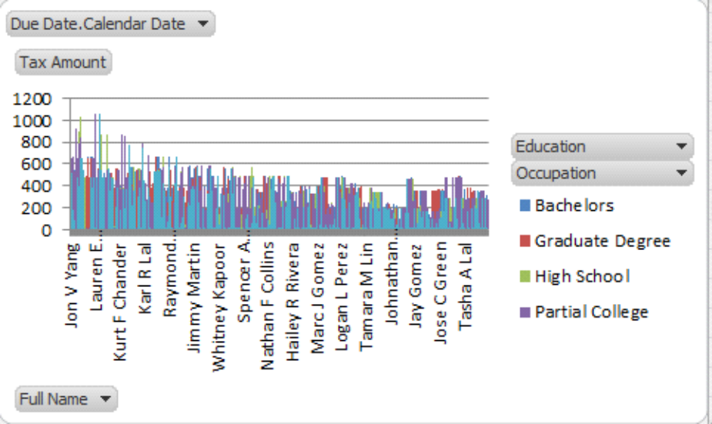
TASK:03
Display the sales amount for all products (use product hierarchy) purchased according to the calendar year and filter the results according to the customers’ genders. What type of customers bought the most Biking products?

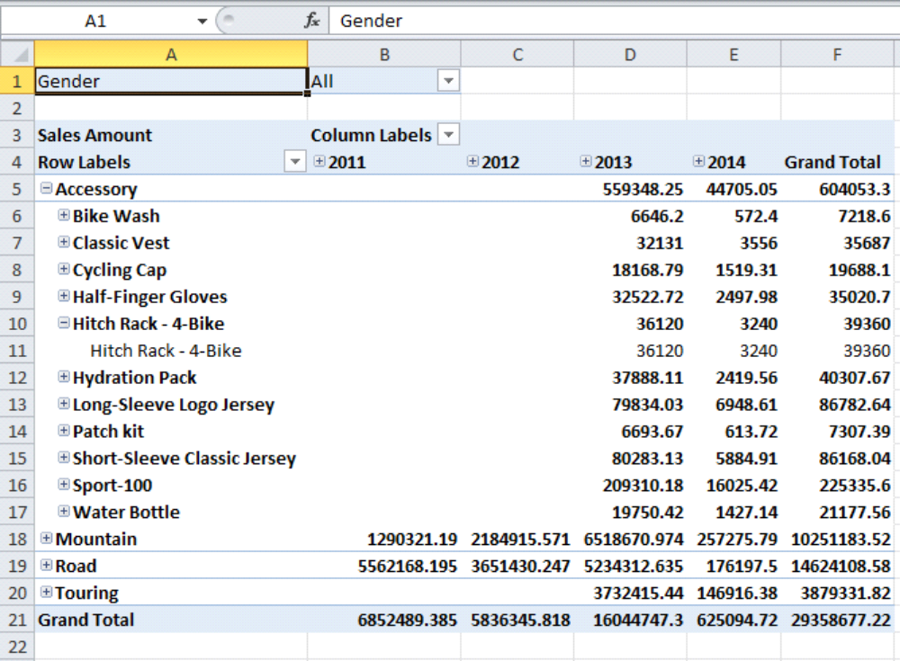

Males purchase more biking products than the Female.
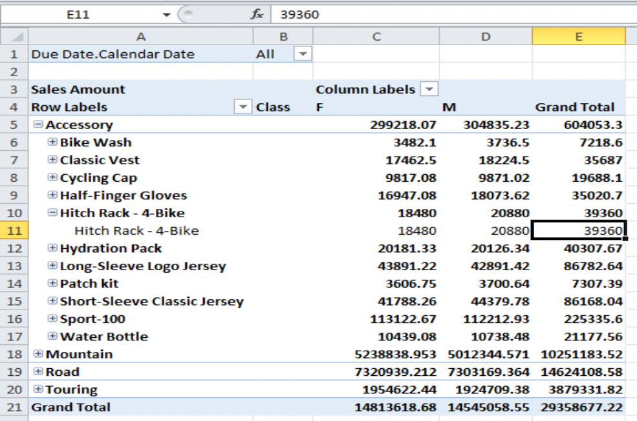

TASK:04
Display the total days required to manufacture the products (use product hierarchy) according to region and time (use date hierarchy).

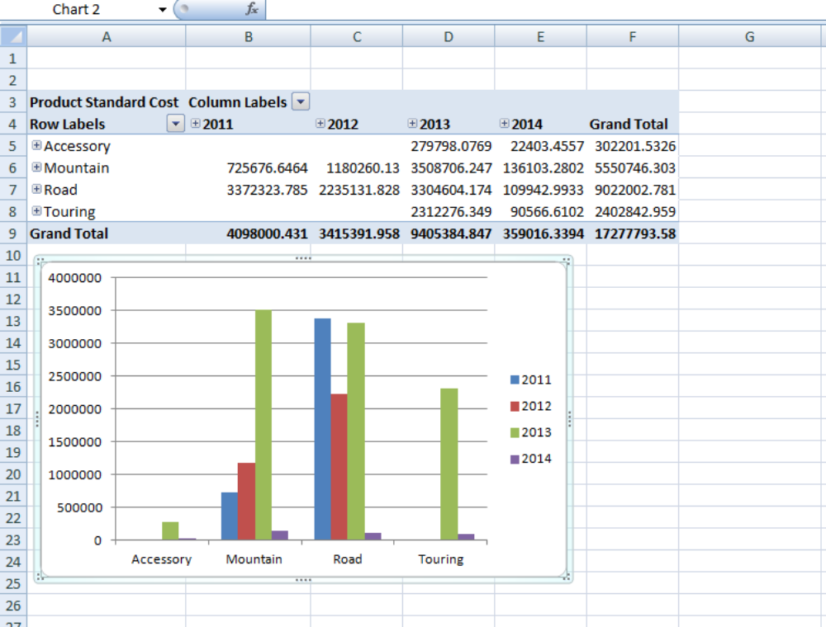
TASK:05
Display the order quantity for all the products ordered by customers according to their marital statuses and genders. Filter the results for customers having yearly income greater than or equal to 50,000.
